SQT Unit-3 (3-10)
Q3)
a) What is Equivalence Partitioning (EP) in software testing, and what is its primary goal?
b) How does Equivalence Partitioning complement Boundary Value Analysis (BVA)?
A)
Here’s a detailed explanation of both parts of your question, based on the uploaded documents:

a) What is Equivalence Partitioning (EP) in software testing, and what is its primary goal?
Equivalence Partitioning (EP), also called Equivalence Class Partitioning (ECP), is a black-box testing technique where the input domain of a program is divided into groups (called equivalence classes). Each class represents a set of valid or invalid inputs that the system should handle in the same way.
- How it works:
Instead of testing every possible input, EP identifies representative values from each equivalence class. If one input in the class works as expected, the assumption is that all other inputs in the same class will behave similarly.
- Guidelines for defining equivalence classes:
  - If input is a range → 1 valid class + 2 invalid classes.
  - If input is a specific value → 1 valid class + 2 invalid classes.
  - If input is a set → 1 valid class + 1 invalid class.
  - If input is Boolean → 1 valid class + 1 invalid class.
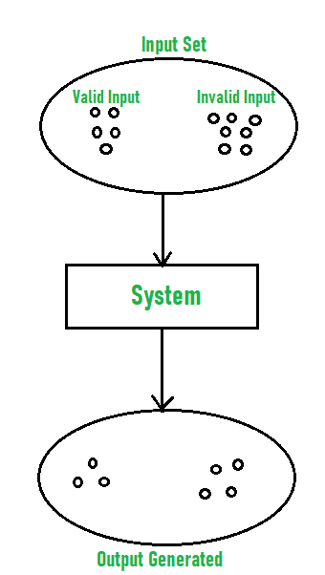
- Example:
If a college admission system accepts percentages between 50% and 90%, EP creates:
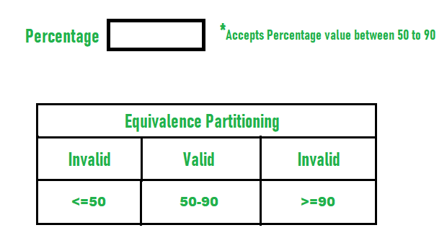
  - Valid class: values 50–90
  - Invalid class: values <50
  - Invalid class: values >90
- Primary Goal:
The main objective of EP is to reduce the number of test cases while still ensuring adequate coverage of the input domain. It avoids redundant testing and ensures efficiency by focusing only on representative test values.

b) How does Equivalence Partitioning complement Boundary Value Analysis (BVA)?
Boundary Value Analysis (BVA) is another black-box testing technique that specifically targets the edges (boundaries) of input ranges, since defects are most likely to occur at these points.
- How BVA works:
For a range (e.g., age 18–60), BVA tests:
  - Just below the minimum (17)
  - Minimum (18)
  - Just above the minimum (19)
  - Just below the maximum (59)
  - Maximum (60)
  - Just above the maximum (61)
- Complementary Role with EP:
  - EP ensures coverage of the entire input domain by selecting representative values from each equivalence class.
  - BVA enhances EP by focusing on the critical edge values within and around those classes.
- Example of Combination:
  - Input condition: Percentage should be between 50–90.
  - EP Test Cases: Representative values → 55 (valid), 45 (invalid <50), 95 (invalid >90).
  - BVA Test Cases: 49 (just below), 50 (min), 51 (just above min), 89 (just below max), 90 (max), 91 (just above).
Together, EP and BVA make test design more efficient and thorough:
- EP avoids unnecessary tests by grouping inputs.
- BVA detects subtle boundary-related errors that EP alone might miss.

✅ Final Summary:
- EP: Divides input data into valid/invalid classes → tests representatives → saves effort.
- BVA: Focuses on edge cases → detects boundary-related defects.
- Complementary: EP gives broad domain coverage, BVA strengthens it by zooming into critical boundaries.

Q4)
a) What is Decision Table Testing, and when is it particularly useful?
b) What are the main components of a Decision Table? Explain each briefly.
A)
Got it 👍 Let’s go step by step using the content from your uploaded slides.

a) What is Decision Table Testing, and when is it particularly useful?
Decision Table Testing is a black-box testing technique that represents complex logical relationships between inputs (conditions) and outputs (actions) in a tabular form.
- Each row or column in the table defines a specific rule that maps a combination of input conditions to the corresponding system action/output.
- Because it shows all possible input combinations and their expected outputs, it is also known as a Cause-Effect Table.
The decision tables are categorized into two types and these are given below:
- Limited Entry: In the limited entry decision tables, the condition entries are restricted to binary values.
- Extended Entry: In the extended entry decision table, the condition entries have more than two values. The decision tables use multiple conditions where a condition may have many possibilities instead of only ‘true’ and ‘false’ are known as extended entry decision tables.
When it is useful:
- It is especially helpful when:
  - The system behavior depends on multiple input conditions.
  - There are complex business rules with many combinations of true/false conditions.
  - The tester wants to ensure complete coverage of all possible input combinations.
- Example:
For a login screen with two conditions (username, password), a decision table can capture:
  - Correct/incorrect username + correct/incorrect password → Home screen or Error message.
In short: Decision Table Testing is particularly useful for testing business logic, rule-driven functionality, and input combinations that affect outputs.

b) What are the main components of a Decision Table? Explain each briefly
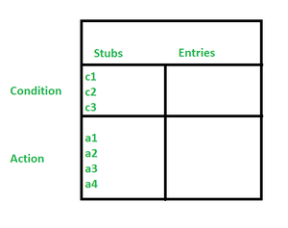
A decision table has four main components, arranged in four quadrants:
- Condition Stubs
  - Located in the upper-left portion of the table.
  - Lists all the conditions (inputs or logical factors) that influence decisions.
  - Example: Username valid? (Yes/No), Password valid? (Yes/No).
- Action Stubs
  - Located in the lower-left portion.
  - Defines the possible actions (outputs) the system can take when the conditions are met.
  - Example: Show error message, Redirect to home page.
- Condition Entries
  - Located in the upper-right portion.
  - Contains the actual values for the conditions under each rule (e.g., True/False, Yes/No).
  - Each column in this part represents a rule, which is a specific combination of conditions.
- Action Entries
  - Located in the lower-right portion.
  - Specifies which actions are taken for each rule (based on the condition entries).
  - Example: If username = T and password = T → action = “Go to Home”; otherwise → action = “Show Error”.

✅ Final Summary:
- Decision Table Testing: A tabular method to test system behavior for different input combinations. Useful for rule-based logic and multiple input conditions.
- Main Components:
  - Condition Stubs → Input conditions.
  - Action Stubs → Possible outputs.
  - Condition Entries → Values (T/F, Yes/No) under each rule.
  - Action Entries → Actions taken for each rule.
Q5) What is State Transition Testing, and when is it most applicable and its advantages?
A)
State Transition Testing
Definition:
State Transition Testing is a black-box testing technique that models the behavior of a system in terms of:
- States → different conditions or modes the system can be in at any time,
- Transitions → changes between states,
- Events → inputs or actions that trigger these transitions, and
- Actions → activities performed by the system when a transition occurs.
It is particularly useful for systems that have a finite number of states and where the system’s behavior is state-dependent.

Key Concepts
- State: A specific condition or situation of the system at a given time (e.g., Logged In, Logged Out, Locked).
- Event: An input or trigger that causes the system to change from one state to another (e.g., user enters a password, timer expires).
- Transition: The actual change of state caused by an event (e.g., from “Locked” → “Unlocked”).
- Action: The operation performed by the system during a transition (e.g., display welcome screen after successful login).

When It Is Most Applicable
State Transition Testing is most useful when:
- The system has complex workflows or business logic that depend on the current state.
- The same input may result in different outcomes depending on the state.
  - Example: Entering a PIN → works if a card is inserted, but ignored if no card is present.
- There is a finite number of states that can be clearly identified.
- Testing requires sequences of events and not just individual inputs.
Typical applications include ATMs, login systems, traffic light controllers, online workflows, and embedded systems.

Steps for State Transition Testing
- Identify all possible states of the system or component.
- Identify all possible events that can trigger state changes.
- Draw a state transition diagram to visualize states, events, and transitions.
  - States = nodes (circles/rectangles).
  - Transitions = arrows.
  - Events = labels on arrows.
- Design test cases to cover:
  - All valid transitions.
  - Invalid transitions (where the state should not change).
  - Each state being visited at least once.
  - Sequences of states and events.

Advantages
- Very effective for testing systems with complex, state-dependent behavior.
- Helps identify dead states (states that cannot be reached) or unreachable transitions.
- Exposes defects related to incorrect state changes or missing transitions.
- Provides a clear and visual representation of how the system behaves.

Disadvantages
- Becomes complex and difficult to manage when the number of states and transitions is very large.
- Requires a deep understanding of the system’s state definitions and event handling to build accurate test models.

Example
Traffic Light System:
- States: Red, Green, Yellow.
- Events: Timer expiry (after predefined durations).
- Transitions:
  - Red → Green (on timer expiry).
  - Green → Yellow (on timer expiry).
  - Yellow → Red (on timer expiry).
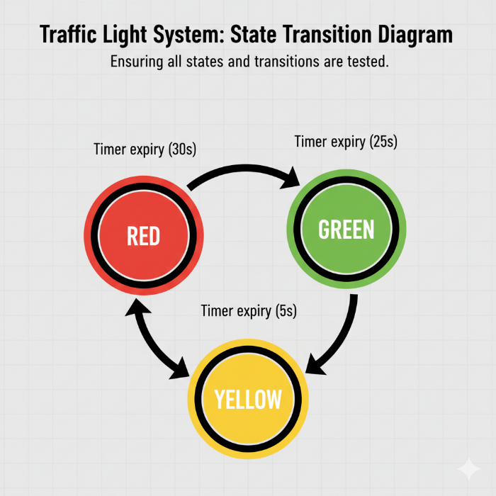
This ensures that all states and transitions are tested for correctness.

Q6) What are the key components of a State Transition Diagram, which is often used in State Transition Testing?
A)
1. Understanding a State Transition Diagram
A State Transition Diagram (STD) is a graphical representation that models the behavior of a system in terms of states and the transitions between those states. It belongs to the family of finite state machines (FSMs).
- States represent the different conditions or situations in which the system can exist.
- Events are triggers or inputs that cause the system to change state.
- Transitions are the actual changes from one state to another when an event occurs.
- Actions are the outputs or activities that occur when a transition happens.
For example, in a traffic light system, the states are Red, Green, and Yellow. The event is a timer expiring, the transition is the change from Red → Green, and the action could be switching on the corresponding signal light.
This modeling technique is particularly important in testing systems where the behavior is state-dependent—that is, the output of the system does not just depend on the input, but also on its current state.

2. Key Components of a State Transition Diagram
a) State
A state is the condition of the system at a particular time. It represents what the system is doing, what rules apply, or what outputs are valid at that moment.
- Definition: A recognizable situation or condition that exists for some period of time in response to events.
- Representation in diagrams: States are usually shown as circles or rectangles labeled with the state’s name.
- Examples:
  - ATM → "Idle", "Card Inserted", "PIN Entered", "Transaction Processing".
  - Login system → "Logged Out", "Logged In", "Locked".
  - Traffic light → "Red", "Green", "Yellow".
Importance in testing:
Identifying all possible states ensures that testers can check the behavior of the system in each condition. Missing a state may lead to undetected defects.

b) Event
An event is something that happens, either as an input from the user, an external trigger, or a system-generated occurrence, that may cause a state transition.
- Definition: A stimulus or trigger that initiates a possible change in the system’s state.
- Representation in diagrams: Events are usually shown as labels on transition arrows.
- Examples:
  - User enters a correct password (event → "Password Entered").
  - A timer runs out (event → "Timer Expiry").
  - A card is inserted into an ATM (event → "Card Inserted").
Importance in testing:
Events are the test inputs. Testers must identify all possible events that can occur in each state and design test cases to verify valid and invalid transitions.

c) Transition
A transition is the change from one state to another, triggered by an event. It represents the system’s movement through its workflow.
- Definition: A directed relationship that indicates how a system moves from one state to another as a result of an event.
- Representation in diagrams: Transitions are shown as arrows connecting states.
- Types of transitions:
  - Valid transition: An event correctly moves the system to the expected new state.
  - Invalid transition: An event occurs but should not be allowed to cause a state change (system remains in the same state or produces an error).
Examples:
- ATM: "Card Inserted" event → transition from "Idle" → "Card Inserted State".
- Traffic light: "Timer Expiry" event → transition from "Green" → "Yellow".
- Login: "3 Failed Attempts" → transition from "Logged Out" → "Locked".
Importance in testing:
Transitions define the flow of the system. Testing ensures that the correct transitions occur and invalid transitions are prevented.

d) Action
An action is the activity the system performs when a transition takes place. It is essentially the output behavior that results from moving between states.
- Definition: The operation executed as a consequence of a transition triggered by an event.
- Representation in diagrams: Actions are often annotated alongside transitions, sometimes after a “/” symbol.
- Examples:
  - ATM: Transition from "PIN Entered" → "Transaction Processing" → Action = “Display transaction menu”.
  - Login: Transition from "Logged Out" → "Logged In" → Action = “Display home screen”.
  - Traffic light: Transition from "Red" → "Green" → Action = “Turn on green light, turn off red light”.
Importance in testing:
Actions represent the expected system behavior. Testers verify whether the correct action occurs for each transition.

3. Supporting Components
Besides the four key elements, state transition diagrams often include some additional components to enhance clarity and completeness.
- Initial State:
  - The starting point of the system before any events occur.
  - Shown as a filled black circle pointing to the first state.
- Final State:
  - A state where the system terminates or finishes the process.
  - Shown as a double circle.
- Guard Conditions:
  - Boolean expressions that must be true for a transition to occur.
  - Example: ATM allows withdrawal only if balance > amount requested.
- Composite States / Nested States:
  - Complex systems may group states into higher-level states for readability.

4. Role of the State Transition Diagram in Testing
A state transition diagram plays a critical role in designing test cases:
- Coverage of States: Ensures every possible state is visited and tested.
- Coverage of Transitions: Helps in creating test cases that verify every valid and invalid transition.
- Detection of Dead States: Reveals states that cannot be reached (design flaws).
- Verification of Actions: Ensures correct system behavior during state changes.
- Testing Sequences: Allows the creation of test scenarios involving multiple states and transitions in sequence (e.g., multiple login attempts).
In essence, the diagram serves as a blueprint for systematic test case generation.

5. Example: Traffic Light System
Let’s consider a traffic light system:
- States: Red, Green, Yellow.
- Events: Timer Expiry.
- Transitions:
  - Red → Green (on timer expiry).
  - Green → Yellow (on timer expiry).
  - Yellow → Red (on timer expiry).
- Actions: Turn on the respective light, turn off the previous light.

Here, the diagram ensures that testers verify:
- The system starts in Red (initial state).
- Every event correctly causes the next transition.
- Invalid events (e.g., skipping directly from Red → Yellow) are not allowed.
- All three states are covered.

6. Advantages of Using State Transition Diagrams
- Provides a clear visual representation of system behavior.
- Helps testers identify unreachable states or missing transitions.
- Supports both valid and invalid transition testing.
- Encourages systematic test design for complex workflows.
- Bridges the gap between requirements and test cases.

Q7)
a) What are the key elements of a Use Case that are relevant for testing?
b) How do you design test cases from Use Cases?
A)
Use Case Testing is a black-box technique derived from use cases. A use case describes how an actor (user or external system) interacts with the system to achieve a goal. Use Case Testing validates the system from an end-user perspective by exercising the main (happy) flow, alternative flows, and exceptional (error) flows. Test design based on use cases emphasizes real business processes and end-to-end behavior.
a) Key elements of a Use Case relevant for testing
Below are the primary use case elements testers must extract and why each matters for designing test cases:
- Use Case Title / ID
  - What it is: A clear name and identifier.
  - Why it matters for testing: Provides traceability to requirements and helps organize test cases (e.g., UC-PlaceOrder).
- Actor(s)
  - What it is: The human user or external system that initiates or participates in the use case.
  - Why it matters: Tests must cover interactions by different actors (e.g., guest user vs. logged-in user vs. admin). Different actors may trigger different flows or privileges.
- Goal / Brief Description
  - What it is: The business objective (what success looks like).
  - Why it matters: Defines the acceptance criteria and the successful end state the test must verify.
- Main Flow (Basic/Happy Path)
  - What it is: The primary sequence of steps that leads to the goal when everything proceeds normally.
  - Why it matters: At minimum, testers must implement end-to-end test(s) for this flow to validate the core functionality.
- Alternative Flows
  - What it is: Optional or variant sequences that still achieve the goal (e.g., apply discount code, login during checkout).
  - Why it matters: Test cases need to cover real-world variations that customers use; they often involve branching and conditional logic.
- Exceptional Flows (Error Flows)
  - What it is: Error conditions or failure paths (invalid payment, out of stock).
  - Why it matters: Verifies robustness, error messages, rollback behavior, and whether the system gracefully handles failures.
- Preconditions
  - What it is: State that must be true before the use case starts (e.g., user has items in cart).
  - Why it matters: Test setup must create these preconditions; otherwise tests are invalid.
- Postconditions / Success Criteria
  - What it is: What must be true after completion (e.g., order confirmed, payment recorded).
  - Why it matters: Provides the exact expected result to assert in test validation.
- Triggers
  - What it is: Event that initiates the use case (user clicks Checkout).
  - Why it matters: Helps create test steps and identify automation hooks.
- Business Rules & Constraints
  - What it is: Special rules (min order value, payment gateway limits).
  - Why it matters: Tests should validate business rule compliance and boundary conditions.
- Data Requirements
  - What it is: Necessary data sets (user profiles, product SKUs, inventory counts).
  - Why it matters: Enables accurate test data design — including positive, negative, and boundary cases.
- Extensions / Sub-use cases
  - What it is: Reusable sequences or nested use cases.
  - Why it matters: Allows modular tests and reuse of common steps (e.g., authentication).
b) How to design test cases from Use Cases
A systematic approach turns each element above into testable artifacts.
Step 1 — Select and prioritize use cases
- Pick use cases based on business criticality and risk. Start with high-priority flows (revenue paths, security-sensitive features).
Step 2 — Analyze flows: main, alternative, exceptional
- Break the use case into discrete sequences: primary path, each alternative, and every exceptional path. Treat each as a separate scenario.
Step 3 — Define preconditions, postconditions, triggers and data
- Specify the exact preconditions (accounts, inventory), postconditions (order confirmation), and the test data required. This reduces flaky tests.
Step 4 — Create test scenarios and map them to test cases
- For each flow create one or more test cases:
  - Happy path test(s): End-to-end positive verification.
  - Alternative flow tests: Each alternative mapping (e.g., apply discount).
  - Exceptional flow tests: Invalid inputs, error states, negative verification.
  - Boundary and data variation tests: Minimum/maximum inputs, nulls, edge values.
  - Integration tests: Cross-module interactions (payment gateway, inventory service).
- Use a test matrix mapping flows → test cases → coverage status.
Step 5 — Write detailed test cases
Use a template with:
- Test Case ID (e.g., TC-UC01-01)
- Title (e.g., Place Order — Happy Path)
- Preconditions
- Test data
- Steps (precise user/system actions)
- Expected result / Postconditions
- Pass/Fail criteria
- Notes (cleanup, dependencies)
Example test case (summarized):
- TC-PlaceOrder-01 — Happy Path
  - Preconditions: user logged in, items in cart, inventory available.
  - Steps: add item → checkout → enter shipping → enter payment → confirm.
  - Expected: payment processed, order confirmed page, order record created.
Step 6 — Include negative and concurrent scenarios
- Negative tests: invalid card, expired coupon, insufficient stock.
- Concurrency: two users checkout same last item — ensure correct stock decrement and user notification.
Step 7 — Add verification points and non-functional checks
- Verify UI messages, DB entries, emails, logs, and audit trails.
- If flows impact performance or security, add performance/load and security tests for key scenarios.
Step 8 — Traceability & maintenance
- Link each test case back to the use case and requirement ID to ensure coverage and ease regression selection. Regularly update tests if use cases change.
Step 9 — Automate wisely
- Automate stable, repeatable happy path and high-priority scenarios. Leave exploratory or complex error handling for manual tests where necessary.
Practical tips
- Involve business analysts to review test flows and acceptance criteria.
- Reuse sub-flows (login, payment) to avoid duplication.
- Keep test data fresh and isolated — use stubs/mocks for external services when necessary.
- Review test cases for completeness: ensure every alternative and exceptional flow from the use case has at least one corresponding test.
Q8) List and briefly describe the common states in a typical Defect Life Cycle.
A)
Common States in a Typical Defect Life Cycle
The Defect Life Cycle (DLC), also called the Bug Life Cycle, represents the step-by-step journey of a defect from its discovery until its closure. Each defect passes through several well-defined states that help teams track progress, maintain accountability, and ensure systematic resolution. Below are the most common states with brief descriptions:
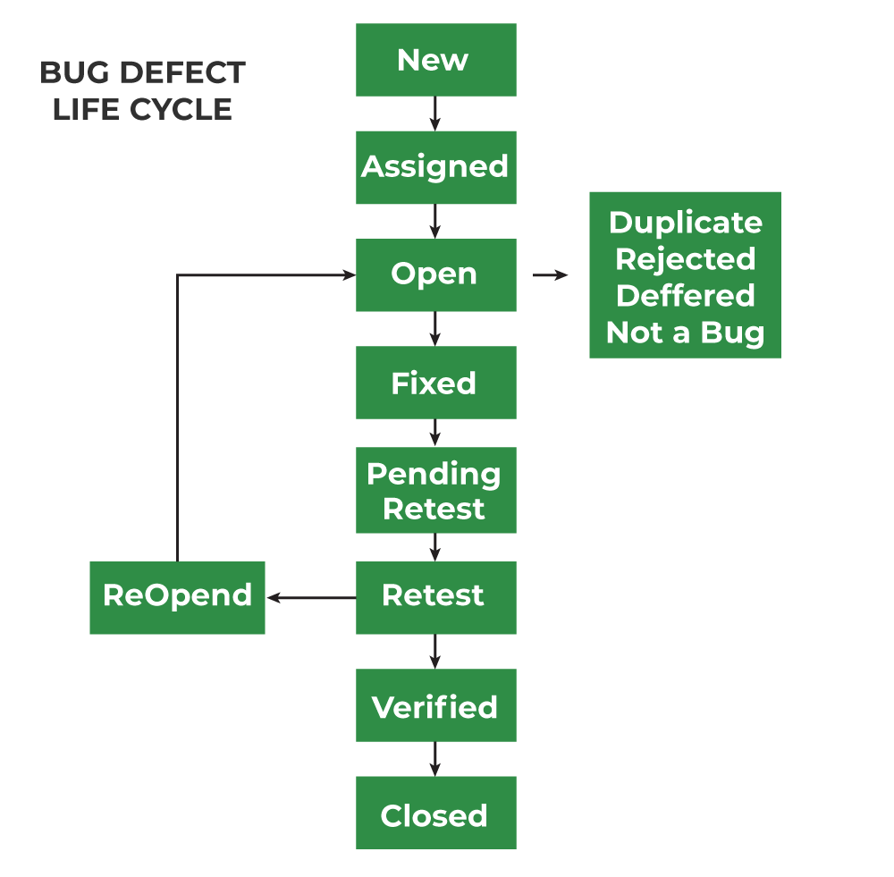

1. New
- Description:
When a tester first identifies a defect during testing, they log it into the defect tracking system. At this point, the defect is marked as New.
- Key Point:
It awaits review by the lead or manager before assignment.

2. Assigned
- Description:
After review, the defect is assigned to a developer or a development team member for further investigation and resolution.
- Key Point:
Responsibility shifts from QA to development.

3. Open / Active
- Description:
The developer has acknowledged the defect and is actively working on analyzing and fixing it.
- Key Point:
Status indicates the bug is in progress and not yet resolved.

4. Fixed
- Description:
The developer applies a code change or configuration adjustment to resolve the defect and marks it as Fixed.
- Key Point:
This doesn’t mean the bug is fully resolved yet — it still requires validation by testers.

5. Pending Retest
- Description:
Once the fix has been moved to the QA/test environment, the defect waits in a Pending Retest state until the QA team retests it.
- Key Point:
This stage ensures the fix is deployed and ready for verification.

6. Retest
- Description:
The QA team re-executes the failed test cases and verifies whether the fix has resolved the issue.
- Key Point:
If the defect no longer appears, it can move to Closed. Otherwise, it may be Reopened.

7. Closed
- Description:
If the QA team confirms that the defect has been fixed correctly and no related issues remain, the defect is marked as Closed.
- Key Point:
Closure indicates the defect’s life cycle is complete.

8. Reopened
- Description:
If retesting shows the defect still exists or the fix caused new issues, QA Reopens the defect and sends it back to development.
- Key Point:
The bug then re-enters the life cycle for further fixing.

9. Rejected / Deferred
- Rejected:
The developer or lead decides that the issue is not a valid defect. This may be because it is:
  - A duplicate,
  - Not reproducible, or
  - “Works as designed.”
- Deferred:
The defect is valid but scheduled for resolution in a future release, often due to low priority or time/resource constraints.

Q9) List at least five key features or functionalities typically found in a good Bug Tracking System.
A)
Key Features of a Bug Tracking System
A Bug Tracking System (BTS), also known as a Defect Tracking System or Issue Tracking System, is a specialized tool that enables software teams to log, track, manage, and report defects efficiently. A good BTS not only records bug information but also supports the entire defect life cycle — from discovery to closure — while enhancing collaboration and accountability.
Below, we discuss five key features of a Bug Tracking System (with detailed explanations) that make it indispensable in modern software development and testing.

1. Defect Logging
The foundation of any bug tracking system is its defect logging capability. When a tester, developer, or end-user identifies a bug, the system must allow them to create a new defect record with all necessary details.
- What is logged:
  - Title or short summary of the defect.
  - Detailed description (what went wrong).
  - Steps to reproduce the issue.
  - Expected vs. actual results.
  - Severity (impact on the system).
  - Priority (urgency of fixing).
  - Environment details (OS, browser, version, device).
  - Attachments like screenshots, screen recordings, or system logs.
- Importance in testing:
Comprehensive logging ensures that developers have all the information they need to reproduce and fix the bug quickly. It minimizes back-and-forth communication, saving valuable time.
- Example:
In Jira, users can file a bug report template with custom fields like “Defect Type,” “Module Name,” or “Release Version,” making the defect easy to trace back to requirements and builds.

2. Status Management
Once defects are logged, they need to move through the Defect Life Cycle (New → Assigned → Fixed → Retest → Closed, etc.). A good BTS provides clear status management features.
- Capabilities:
  - Track the current state of a defect (e.g., Open, Fixed, Closed, Reopened).
  - Allow customization of workflows to match an organization’s processes.
  - Show history of state changes (who changed the status, when, why).
- Benefits:
Status management ensures visibility into the progress of defect resolution. It prevents defects from being forgotten, overlooked, or left unresolved. Managers and QA leads can track how many bugs are in progress, blocked, or pending retest.
- Example:
In Bugzilla, status fields like UNCONFIRMED, ASSIGNED, RESOLVED, VERIFIED, CLOSED clearly communicate where each defect stands.

3. Assignment & Workflow
Another critical feature is the ability to assign defects to individuals or teams and define workflows for resolution.
- Assignment Features:
  - Assign each bug to a responsible developer or team.
  - Reassign bugs if needed (e.g., wrong module, unavailable developer).
  - Notify assignees automatically of their tasks.
- Workflow Management:
  - Define and enforce defect-handling workflows (e.g., who can move a bug from Open to Closed).
  - Prevent unauthorized status changes.
  - Customize workflows for different projects or teams.
- Benefits:
  - Provides clear accountability: every defect has an owner.
  - Avoids confusion or duplication of effort.
  - Ensures that bugs move smoothly through stages without bottlenecks.
- Example:
In Azure DevOps, bugs can be linked to specific backlog items and automatically assigned to sprint teams with pre-defined workflows.

4. Prioritization & Severity
Not all defects are equal. Some may crash the entire system (critical), while others may be minor UI misalignments. A good BTS allows classification of defects by severity and priority.
- Severity (Impact):
  - Defines the seriousness of the bug.
  - Levels: Critical, Major, Minor, Trivial.
  - Example: System crash = Critical; Typo in UI = Minor.
- Priority (Urgency):
  - Defines how soon the bug must be fixed.
  - Levels: High, Medium, Low.
  - Example: Critical bug before release → High priority.
- Benefits:
  - Helps teams allocate resources effectively.
  - Ensures critical bugs are addressed first.
  - Aligns bug fixing with project deadlines.
- Example:
In Jira, custom fields allow tagging defects with “P1, P2, P3” (priority) and “Blocker, Critical, Major” (severity). This helps stakeholders balance risk vs. time.

5. Reporting & Analytics
A mature BTS is not just about recording defects — it also analyzes defect data to provide insights into software quality and team performance.
- Key Reports:
  - Defect trends over time.
  - Open vs. closed defects count.
  - Defect density (number of bugs per module or LOC).
  - Average resolution time (time from New → Closed).
  - Distribution of defects by severity/priority.
- Analytics Use Cases:
  - Identify modules with the highest defect rates (quality hotspots).
  - Track progress during test cycles and releases.
  - Forecast timelines for defect resolution.
  - Continuous improvement of development and testing processes.
- Benefits:
  - Empowers project managers with data-driven decision-making.
  - Improves future estimations and quality assurance.
  - Increases visibility for stakeholders.
- Example:
Jira dashboards provide charts like “Defects by Status,” “Defects by Priority,” and “Defects Created vs. Resolved,” helping management monitor release readiness.

Additional Features (Beyond the Five)
While the above five are core, many modern BTS tools provide extra functionalities that enhance collaboration and efficiency:
- Search & Filtering: Quickly find defects by keywords, severity, or assignee.
- Notifications: Automatic alerts for new assignments, comments, or status changes.
- Collaboration Tools: Threaded comments, attachments, and discussion history.
- History / Audit Trail: Complete log of all changes made to the defect.
- Integration: Sync with version control (Git), CI/CD pipelines (Jenkins), and test management tools.

Q10) What is the difference between "Severity" and "Priority" in bug tracking?
A)
